Projet Git Antonin Bernard

Etape 1 : se connecter au projet en commun sur github.com
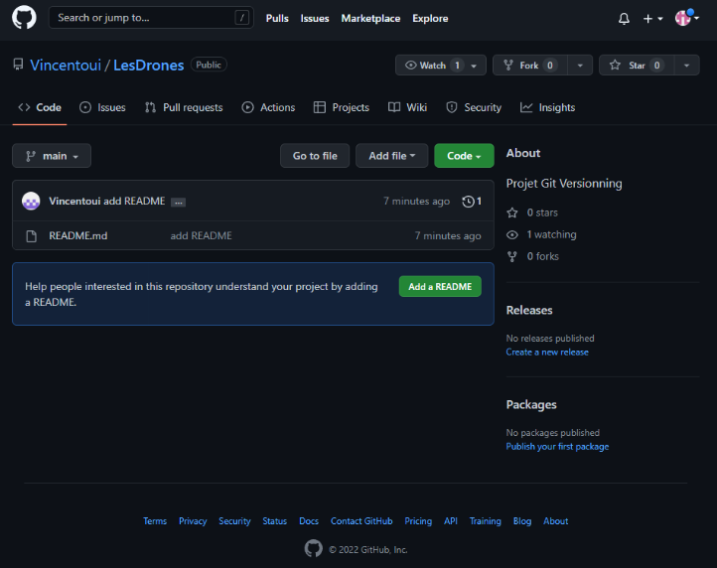
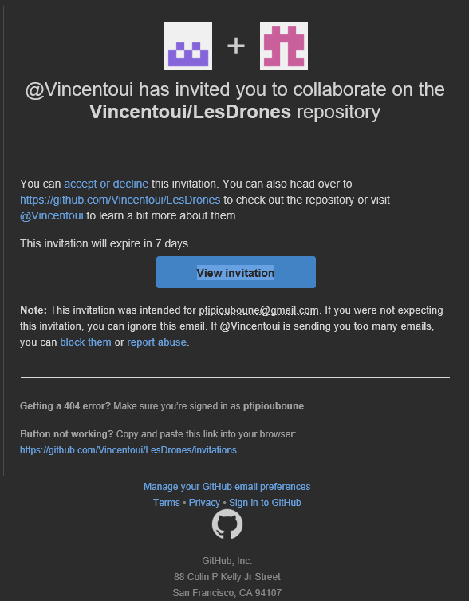
Etape 2 : récupérer le projet de GitHub et le copier sur le pc
- Git clone git@github.com:Vincentoui/LesDrones.git
- Git pull

Etape 3 : modifier le programme (changer l’index, changer le php, changer le css, enlever les fichiers non voulus, faire une nouvelle page) en créant 4 branche différente (ChangeIndex, suppression_php, ChangeStyle, removeFile)
Répartition des taches :
- Mathis : suppression_php
- Vincent : removeFile
- Thibaut : ChangeStyle
- Antonin : ChangeIndex
- Antonin : NouvellePage

Mathis commande :
Git checkout ‘’suppression_php”
(modification et suppression sur le php)
Git add .
Git commit -m ‘’php_supprimé’’
Git pull
Git push (ne marchait pas car la branche n’existait pas sur le repository distant)
Git push --set-upstream origin suppresion_php
Git checkout main
Git merge suppression_php
Git push
-----------------------
Git checkout ChangeIndex
(modifier index.html au même endroit que Antonin)
Git add .
Git commit -m ‘’conflit’’
Git pull
(conflit entre Mathis et antonin, Mathis à choisis ses modif)
Git commit -m ‘’conflit résolu’’
Git push
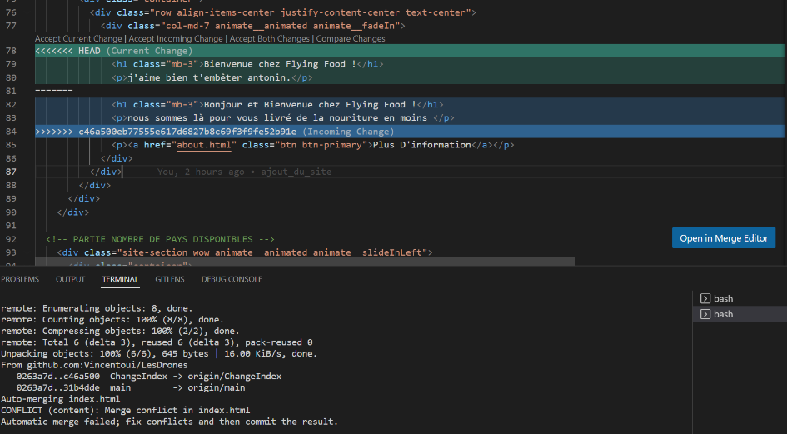

Vincent commande :
Git checkout ‘’removeFile”
Git push --set-upstream origin removeFile
Git branch removePHP
Git branch ChangeIndex
Git branch ChangeStyle
Git branch ChangePHP
Git branch
Git checkout removePHP
Git branch -M removeFile
Git branch
Git checkout main
Git branch
Git pull
Git push -u origin main
Git checkout removeFile
Git push -u origin main
Git branch
Git push --set-upstream origin removeFile
Git branch
Git checkout ChangeIndex
Git log
Git checkout changePHP
Git push –set-upstream origin changePHP
Git checkout main
Git pull
Git checkout ChangeStyle
Git push –set-upstream origin ChangeStyle
Git checkout main
Git pull
Touch .gitignore
Git add .
Git commit -m ‘’ignoring js/scss/php’’
Git pull
Git push -u origin main
Git checkout removeFile
Git pull
Git checkout main
Git push -u origin main
Git checkout removeFile
Touch .gitignore
Git add .
Git commit
Git pull
Git push origin
Git push
Git merge main
Git add .
Git commit -m ‘’merge”
Git status
Git add .
Git commit -m ‘’add gitignore”
Git pull
Git push origin removeFile
Git status
Git checkout main
Git status
Git pull
Git merge removeFile
Git pull
Git push origin main
Git checkout ChangeIndex
Git pull origin ChangeIndex
Git add .
Git status
Git commit -m ‘’change the media’’
Git status
Git log --pretty=oneline

Thibaut commande :
Git checkout ‘’ChangeStyle”
Git push --set-upstream origin ChangeStyle
git checkout --track origin/my-branch-name
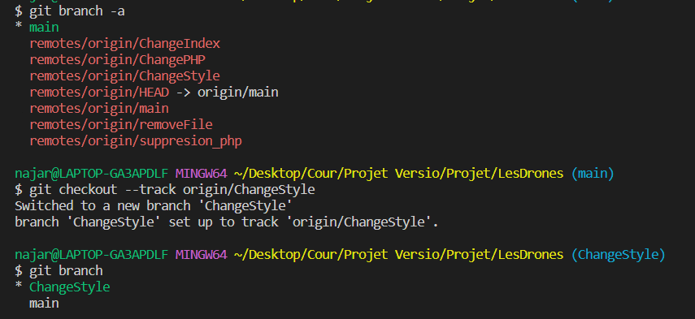
(modifier CSS au hasards)
Git add .
Git commit -m ’’modif style’’
Git pull origin ChangeStyle
Git push -u origin ChangeStyle
Git checkout main
Git pull
Git merge ChangeStyle
Git push

Antonin commande :
Git branch
Git checkout ‘’ChangeIndex’’
Git push --set-upstream origin ChangeIndex
Git checkout --track origin/ChangeIndex
Git fetch --all
(modifier le dossier index.html)
Git add .
Git status
Git commit -m ‘’changement description’’
Cd ..
Git pull
Git chekout -b ‘’NouvellePage’’
Git touch PageAchat.html
Git status
Gid add .
Git status
Git commit -m ‘’hello, world !’’
Git status

